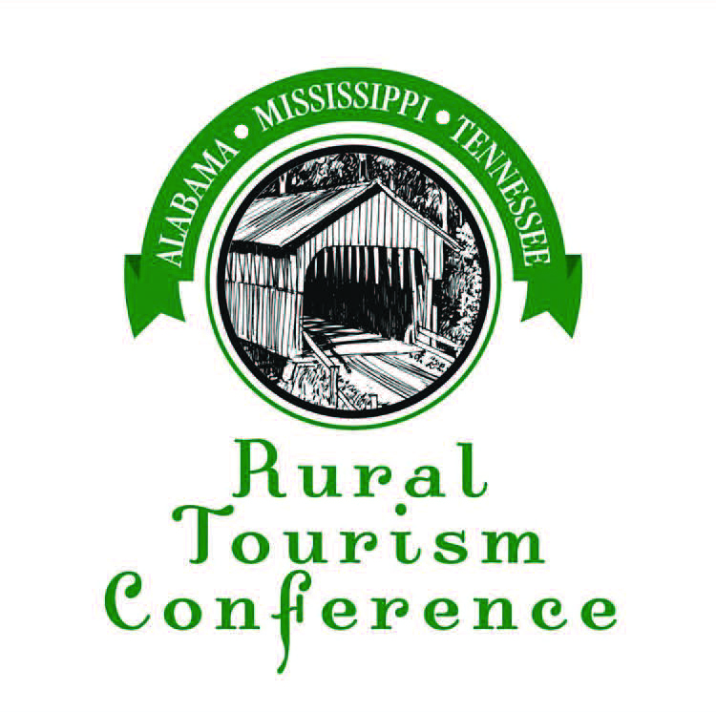

Tennessee Scholarship

2021
Ala-Miss-Tenn Rural Tourism Conference

Scholarship Form

Name and Title:

Organization:

Address:

City: State: Zip:

Email:

Phone:

Your Name if Nominating Someone:

**Please submit along with this form, a short description of why you would like to attend the Alabama-Mississippi-Tennessee Rural Tourism Conference and how it would benefit you and your organization. Also give a brief description of what Rural Tourism aspects your community promotes.

**If you are nominating someone for this scholarship other than yourself, please attach in writing why you think this person should receive this scholarship and how this conference would benefit their continuing education.

DEADLINE: August 20, 2021

Mail to:

Mary Beth Hopper
P.O. Box 10543
Jackson, TN 38308

www.almstnruraltourism.com

