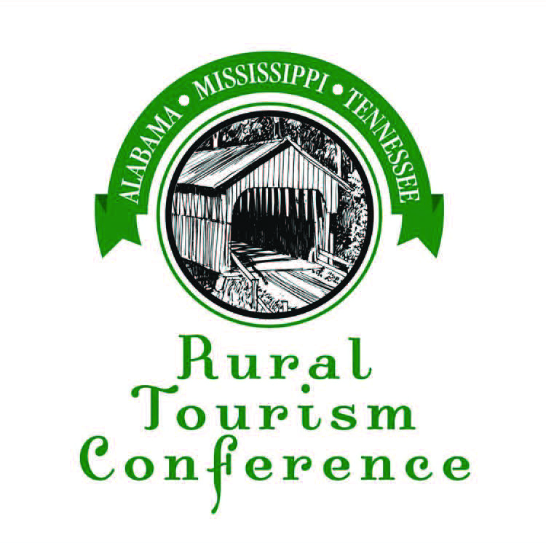

2021

The Agnes Zaiontz
Rural Tourism Leadership Award

Described as the mother of economic development efforts along the Tennessee-Tombigbee Waterway and the glue that held the Waterway together, Agnes Zaiontz was a fixture at the Tenn-Tom Waterway Development authority for nearly 35 years. She carried the title of office manager, but her roles reached far beyond her job description and title. She was instrumental in the development of the Tennessee-Tombigbee Tourism Association and the Tenn-Tom Marina Association, where she oversaw grant writing, bookkeeping, accounting, payroll and association management.

Through her work, she touched many lives and is one of the most well-known, beloved and respected people connected to the Tenn-Tom Waterway. Recognized by Southern Business & Development magazine as one of “Ten People Who Made a Difference in the South,” our beloved Agnes passed away May 29, 2019.

This award recognizes a person or organization that has made a significant contribution to the rural travel and tourism industry through inspiration, spirit and excellent leadership.

Deadline for entries must be received by September 3, 2021
Mail, Email or Fax nomination forms to
Tourism Awards Committee P.O. Box 2537 Decatur, AL 35602
Fax 256-350-3519 or Email tami@northalabama.org

Person Submitting Nomination:_

Your Business Affiliation:

Your Address:

Your Telephone:

Please attach a brief statement explaining why this nominee is deserving of the award, along with their name, address, business affiliation and contact info.

